Tutorial 1 - MySQL Tutorial for Beginners
MySQL is a popular relational database management system that is used for storing and managing data. This tutorial will guide you through the basics of MySQL, covering installation, basic commands, and fundamental concepts.
Table of Contents – Tutorial 1
- Installation
- Connecting to MySQL
- Basic Commands
  - Creating a Database
  - Creating a Table
  - Inserting Data
  - Querying Data
  - Updating Data
  - Deleting Data
- Conclusion
Table of Contents – Tutorial 2
- Installation walkthrough screenshots (May vary slightly between versions)
- Exercise – Test your Database
- Conclusion
Table of Contents – Tutorial 3
- Inner Join
- Left Join
- Right Join
- Full Outer Join
- Conclusion

Installation
To install MySQL, follow these steps:
- Download MySQL Community Server from the official MySQL website.
- Run the installer and follow the installation wizard instructions.
- Configure MySQL (set root password, select server type, etc.).
- Start the MySQL server.
Connecting to MySQL
You can connect to MySQL using the command line or a GUI client like MySQL Workbench.
Using Command Line
mysql -u root -p
- -u root: specifies the username (root by default).
- -p: prompts for your password.
Using MySQL Workbench
- Open MySQL Workbench.
- Click on the + icon to create a new connection.
- Enter your connection details and click Test Connection.
Basic Commands
Creating a Database
To create a new database, use the following command:
Syntax:
CREATE DATABASE database_name;
Example:
CREATE DATABASE college_db;

------------------------------------------------------------------------------------------------------------------------

Creating a Table
To create a table, use the following syntax:
CREATE TABLE table_name (
column1_name column1_datatype,
column2_name column2_datatype,
...
);
Example:
CREATE TABLE users (
id INT AUTO_INCREMENT PRIMARY KEY,
name VARCHAR(100),
email VARCHAR(100)
);
------------------------------------------------------------------------------------------------------------------------
Inserting Data
To insert data into a table, use:
INSERT INTO table_name (column1, column2, ...) VALUES (value1, value2, ...);
Example:
INSERT INTO users (name, email) VALUES ('John Doe', 'john@example.com');
------------------------------------------------------------------------------------------------------------------------

Querying Data
To retrieve data from a table, use:
SELECT * FROM table_name;
Example:
SELECT * FROM users;
------------------------------------------------------------------------------------------------------------------------

Updating Data
To update existing data in a table, use:
Syntax:
UPDATE table_name SET column1 = value1, column2 = value2 WHERE condition;
Example:
UPDATE users SET email = 'john.doe@example.com' WHERE name = 'John Doe';
------------------------------------------------------------------------------------------------------------------------

Deleting Data
To delete data from a table, use:
DELETE FROM table_name WHERE condition;
Example:
DELETE FROM users WHERE name = 'John Doe';
------------------------------------------------------------------------------------------------------------------------

Conclusion
This tutorial covered the fundamentals of MySQL, including installation, connecting to the database, and basic commands for managing data. As you become more familiar with MySQL, you can explore advanced topics such as indexing, joins, and stored procedures

Tutorial 2 - Installing MySQL

1/ Download the MySQL Community Edition Server installer from MySQL :: Download MySQL Installer

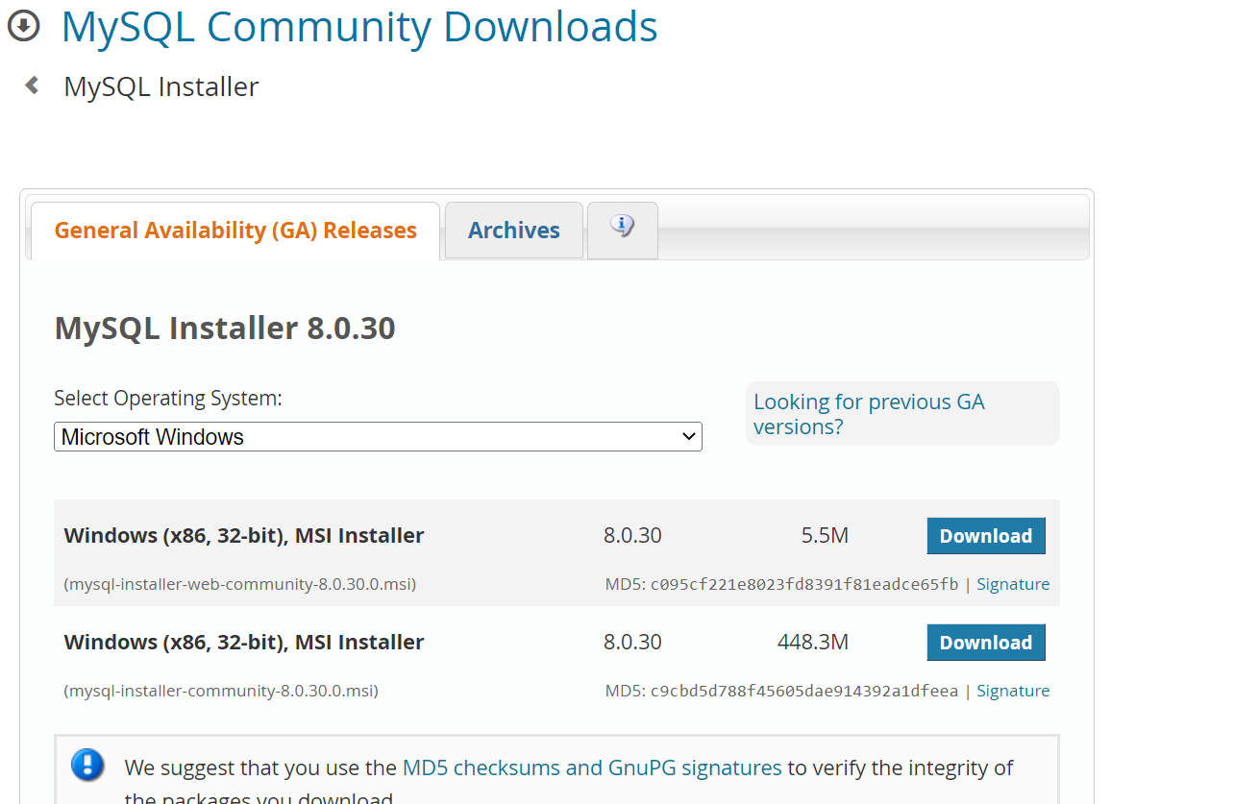

2/ Accept the License Terms and select “Server only”

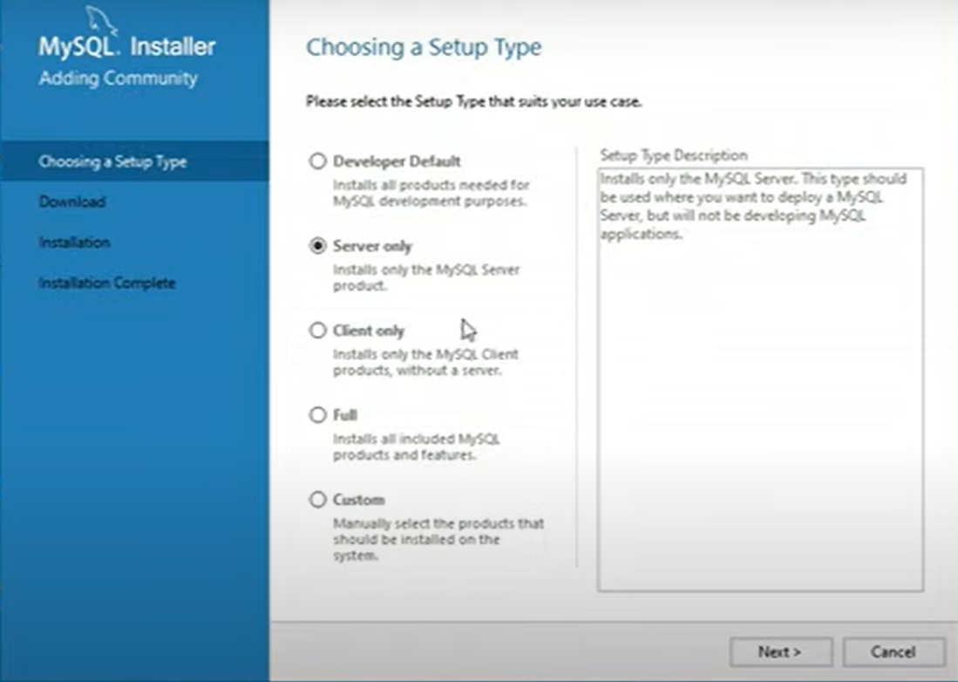

3/ Click the Execute button to install

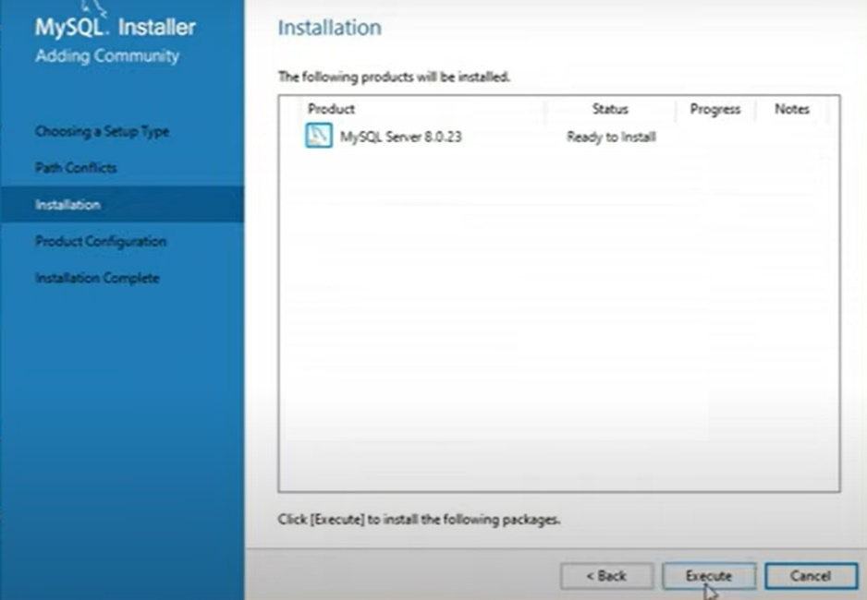

4/ If asked, choose the “Standalone MySQL Server” option and Next to continue
(I didn’t get this option)

5/ Select “Development Computer” as the server configuration

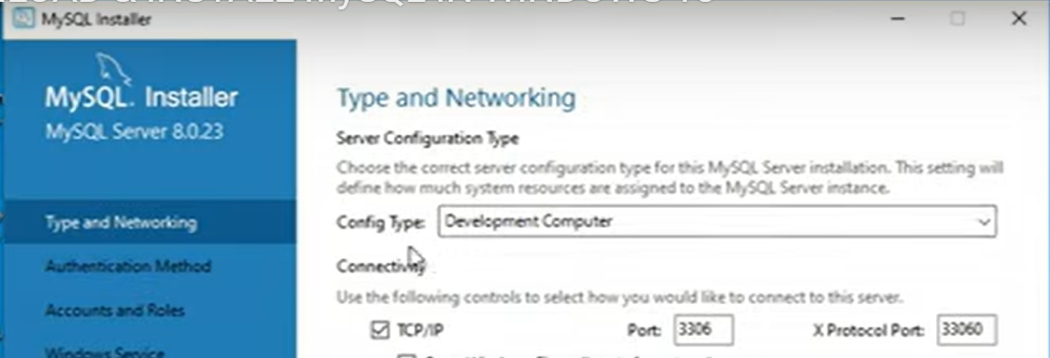

6/ Select “Use Strong Password Encryption for Authentication” then click Next



7/ Enter (Twice if asked to repeat) a Root User password
– KEEP A SEPARATE NOTE OF THIS PASSWORD

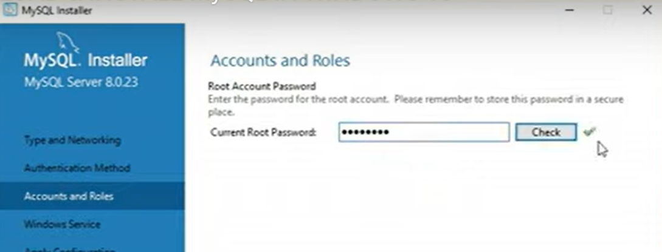

8/ Have you written your password down? – IF NOT DO IT NOW!

9/ Click Next to run as a Windows Service, Next to ignore Plugins and Execute to install

Exercise

Launch MySQL Command Line Client from the group in the Start menu

Use your root password to login

Enter password:********************

This should give you a prompt

mysql>

BEFORE WE PROCEED – Note that MySQL is case sensitive and if you are not confident It might be better to copy and paste your commands from this document. Your Word Doc may hide underscore characters under a red squiggly line as it thinks they are a spelling error.

Type the following SQL Statement carefully – make sure to include the semi-colon

CREATE DATABASE IF NOT EXISTS web_site_db;

Try the following – remember the semi-colon at the end of each statement

SHOW DATABASES;

Now we will create a database user with your own first name and a password of “pa55word” – Nb: Be careful to only add the semi-colon at the end of the whole statement ie: not each line

CREATE USER IF NOT EXISTS ‘graeme’@’localhost’
IDENTIFIED WITH mysql_native_password BY ‘pa55word’;

Now we will grant our user some privileges

GRANT SELECT, INSERT, UPDATE ON web_site_db.*
TO ‘graeme’@’localhost’;

Now try

SHOW GRANTS FOR ‘graeme’@’localhost’;

Okay – Let’s create a simple table in our database
Run the following statement

CREATE TABLE IF NOT EXISTS users (
user_id INT UNSIGNED NOT NULL AUTO INCREMENT,
fname VARCHAR(20) NOT NULL,
lname VARCHAR(20) NOT NULL,
eml VARCHAR(50) NOT NULL,
PRIMARY KEY(user_id),
UNIQUE(eml));

Now let’s check that has worked
Try the following

EXPLAIN users;

You should now see the details of your table

user_id INT UNSIGNED NOT NULL AUTO INCREMENT, - means that the user_id field holds non negative whole numbers, the field must have a value and the numbers will increment or count up by 1 each time.

VARCHAR(20) is a field that takes a 20 character string

NOT NULL means the field must have a value

PRIMARY KEY(user_id) means that user_id field has been configured as the unique identifier field for the table

UNIQUE(eml) means that this field must also hold unique values

Conclusion
Congratulations if you have reached this far, we now have a basic relational database with one table waiting for us to populate it with some data.

Tutorial 3 - MySQL **Join** Feature Tutorial

In this tutorial, we'll explore the **JOIN** feature in MySQL using two sample tables: **students** and **courses**. We'll cover the different types of joins and provide example queries for each type.

Sample Tables

Students Table
student_id, | name, age, | age | course_id
1 | Alice | 20 | 101
2 | Bob | 21 | 102
3 | Charlie | 22 | 101
4 | David | 23 | NULL

Courses Table
course_id | course_name
101 | Mathematics
102 | Science
103 | Literature

Types of Joins
An **INNER JOIN** returns records that have matching values in both tables.
Example:
SELECT s.name, c.course_name
FROM students s
INNER JOIN courses c ON s.course_id = c.course_id;
Result:
Name | Course_name
Alice | Mathematics
Bob | Science
Charlie | Mathematics
A **LEFT JOIN** returns all records from the left table (students), and the matched records from the right table (courses). If there is no match, NULL values are returned for columns from the right table.
Example:
SELECT s.name, c.course_name
FROM students s
LEFT JOIN courses c ON s.course_id = c.course_id;
Result:
name | course_name
Alice | Mathematics
Bob | Science
Charlie | Mathematics
David | Null

A **RIGHT JOIN** returns all records from the right table (courses), and the matched records from the left table (students). If there is no match, NULL values are returned for columns from the left table.
Example:
SELECT s.name, c.course_name
FROM students s
RIGHT JOIN courses c ON s.course_id = c.course_id;
Result:
name | course_name
Alice | Mathematics
Bob | Science
Charlie | Mathematics
NULL | Literature

MySQL does not directly support **FULL OUTER JOIN**, but you can simulate it using a combination of **LEFT JOIN** and **RIGHT JOIN** with a **UNION**.

Example:
SELECT s.name, c.course_name
FROM students s
LEFT JOIN courses c ON s.course_id = c.course_id

UNION

SELECT s.name, c.course_name
FROM students s
RIGHT JOIN courses c ON s.course_id = c.course_id;
Result:
name | Course_name
Alice | Mathematics
Bob | Science
Charlie | Mathematics
David | NULL
NULL | Literature

Conclusion
In this tutorial, we've covered the basic types of **JOIN** in MySQL using **students** and **courses** tables. Understanding these joins is crucial for effectively querying relational databases.

